
Dhaka International University
Lab Report details:
Lab Report Topic : Java Class Implementation and Variable Display & Method Overloading in Java.
Lab Report No : 07
Course Title : Object-Oriented Programming Languages
Course Code : 0613-202

Submitted By: | Submitted To:
S M Nabil Ausaf  Roll: 01  Reg No: CS-D-91-23-124492 | Prof. Md. Abdul Based

Date of Submission: 15 Nov 2024

Code 1: Java Class Implementation and Variable Display
Objective:
The objective of this lab is to know the basics of declaring a class, initializing different types of variables, and calling methods in Java. We are going to implement a simple Java class that declares and then prints the values of different types of variables.
Components Used:
1. Java Development Kit (JDK)
2. Integrated Development Environment (IDE) or any code editor. For example: Eclipse, IntelliJ, Visual Studio Code
3. Java Programming Language
Theory:
Java is an object-oriented language that enables its users to write reusable code through the use of classes and objects. A class in Java is basically a template that defines properties, in the form of variables, and behavior, in the form of methods. Variables in Java can be one of several data types short, long , int , among others, are different types of variables in Java. Each of these types has an explicit range:
short: A 16-bit signed integer. Its range is from -32,768 to 32,767.
long: A 64-bit signed integer. It has a big range and supports big values.
The program below uses these short and long data types. Also, a simple method D () is used which prints the values of these variables when called.
Code:
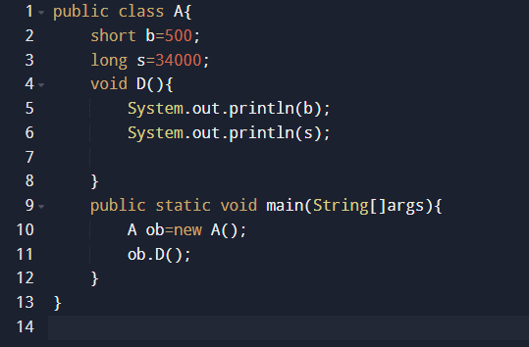

Problem Solving Procedure:
- Define Class and Variables: Define a public class named A.
- In this class, we define two variables: b of type short and s of type long.
- We initialize b with 500 within the range of the variable short and s with 34000 within the range of the variable long.
Next, we define a method named D() within the class. This is just for the purpose of displaying the values of b and s via System.out.println().
Define the main Method:
- We declare the main method which is the entry point of the program.
- Inside the main, we declare an object (ob) of class A.
- We call the D() method with this object. With that call, it prints the values of b and s.
Run the Program:
The program should compile and run successfully. And it should display the values of 'b' and 's'
Discussion:
- A class having two instance variables namely b of type short and s of type long, initialized with some values.
- D () is a member function of class A, invoked using the object instance of the class.
- In main, an instance ob of class A is created and using which we invoke the method D that prints the values of b and s.
The output of the program will be:
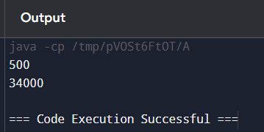
Conclusion:
The program below explain the declaration and usage of variables of different data types inside a class and also the calling of methods on an object instance. This experiment shows that short and long variables are printed correctly when used in the System.out.println function. This exercise reinforces the basic syntax, data types, and object-oriented notions in Java.

Code 2: Method Overloading in Java
Objective:
The objective of this lab is to demonstrate the concept of method overloading in Java by creating multiple methods with the same name but different parameter lists. We will observe how Java differentiates these methods based on their parameters.
Components Used:
1. Java Development Kit (JDK)
2. Code editor or IDE, such as Eclipse, IntelliJ IDEA, or Visual Studio Code
3. Java Programming Language
Theory:
Method overloading in Java allows a class to have more than one method with the same name, differentiated by the number or type of parameters. This feature enhances code readability and usability, as it allows the same method name to be reused for similar operations.
For instance:
- D (int a): accepts one integer parameter.
- D (int a, int b): accepts two integer parameters.
- D (int a, double b): accepts an integer and a double parameter.
Java differentiates overloaded methods by examining the number and type of parameters provided in the method call, selecting the correct method to execute.
Program Code:
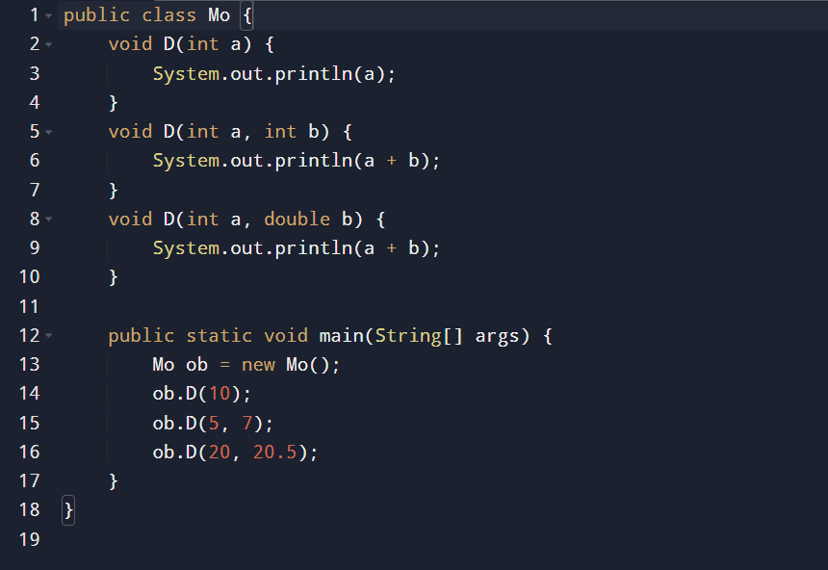

Problem-Solving Procedure:
1. Define the Class and Methods:
- We create a class named Mo.
- Inside this class, we define three versions of the method D:
- D (int a): A method that takes one integer and prints its value.
- D (int a, int b): A method that takes two integers and prints their sum.
- D (int a, double b): A method that takes an integer and a double, printing their sum.
2. Method Overloading:
- By using different parameter lists, we overload the D method, giving it multiple definitions within the same class.
3. Define the main Method:
- The main method is the program entry point, where we create an instance (ob) of the class Mo.
We call each version of the overloaded D method by passing different arguments:
- ob.D(10): Calls the D(int a) method.
- ob.D(5, 7): Calls the D(int a, int b) method.
- ob.D(20, 20.5): Calls the D(int a, double b) method.
4. Run the Program:
- Compile and run the program to verify that each overloaded method is called correctly based on the parameters passed.
Output:
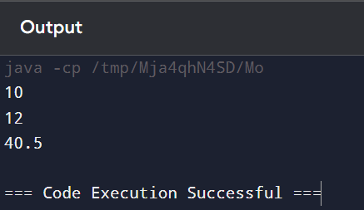

Discussion:
Method Overloading: The program correctly demonstrates method overloading, with the Java compiler selecting the appropriate D method based on the argument types and number of parameters.
Objective and Advantage of Method Overloading:
Method overloading is done so as to provide multiple ways of dealing with similar functionalities without having to come up with unique method names. This would make code simpler because we can use one name to deal with various similar operations: D in this case. It also facilitates future improvements due to the ability to call the same method with different parameters and simplifies the future process, thereby reducing the future need to rename or refactor methods.
Output Explanation:
- ob.D(10); :calls the D(int a) method, printing 10.
- ob.D(5, 7); :calls the D(int a, int b) method, printing 5 + 7 = 12.
- ob.D(20, 20.5); : calls the D(int a, double b)` method, printing 20 + 20.5 = 40.5.
Conclusion:
This lab successfully demonstrates the concept of method overloading in Java. Through multiple methods with the same name and different parameter lists, we can perform similar actions with different inputs, improving code readability and flexibility. The program validates that Java’s method overloading mechanism functions as expected by choosing the correct method version based on argument type and count, producing the intended output for each call.

